Logging into Anthology

You will receive an email notifying you of work ready to be accessed in Anthology. Click on the Go to Anthology link in the email.

If you cannot find the original email from Anthology, go to https://niu.chalkandwire.com/Login.aspx and click the RETRIEVE LOST INVITATION link.

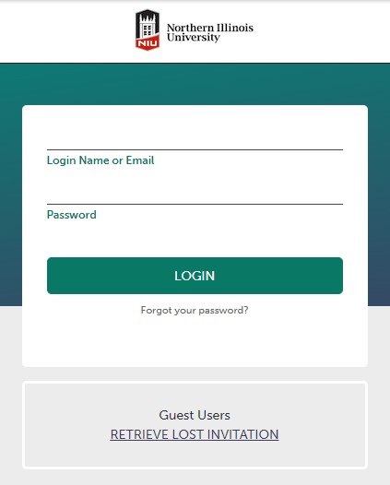

The confirmation bubble pop-up then will direct you to access the new invitation in the new email:

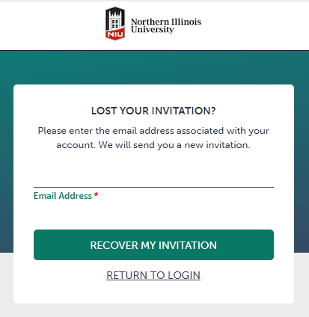

This is what the email looks like:
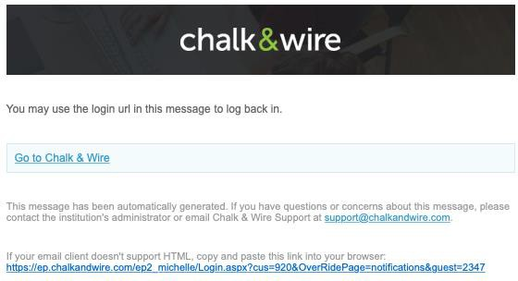

Once you are logged in through the invitation or pending sign-off link, this screen is where you will find all your completed/pending tasks/invitations.

The next actions depend on the task. Typically, this would be completing a placement survey form, assessment rubric form or sign-off approval for a journal of logged hours.

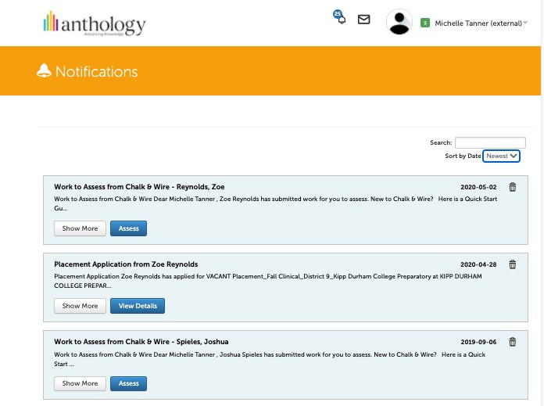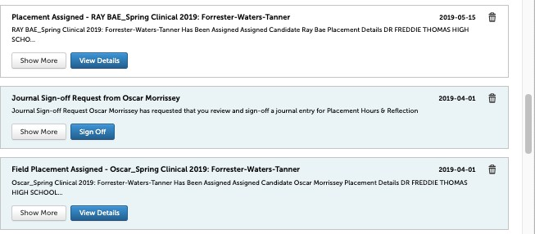

If you clicked a completed sign-off, this screen would show there is nothing to do. You can also click on the ‘Placements’ tab to go to Experiential Learning and see all the placements they have been assigned.

Also, please note the user guide link on the top left under the logo: http://userguide.chalkandwire.com/m/Administrator/l/405359-view-pending-sign-offs. The instructions are the same for a guest even though the screenshot in the guide is for an assessor.

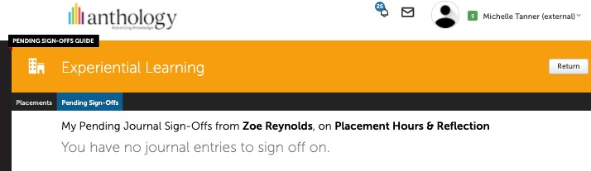

If you click on the placement tab, you can also click to view the details of placements with which you are assigned and associated:
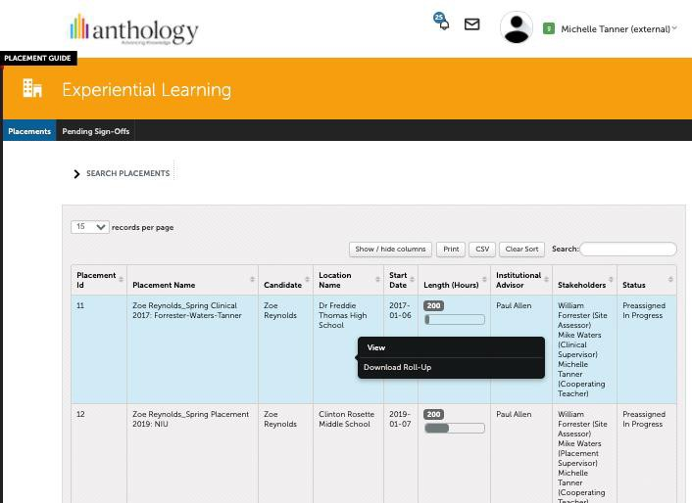
This is how you could go back and look at a journal that you have signed off. You can also view the assessments and surveys you have completed.

When you click to view, this is the screen (partial page):
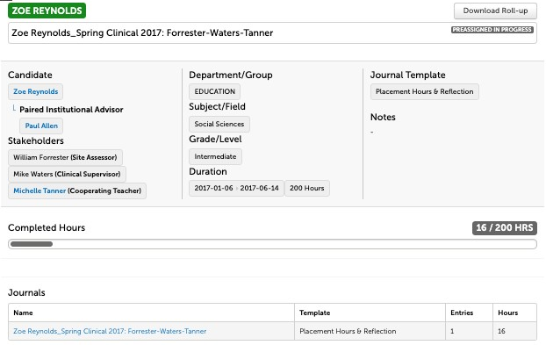

When you click on the journal name (blue text), you can view the details and see you have signed off.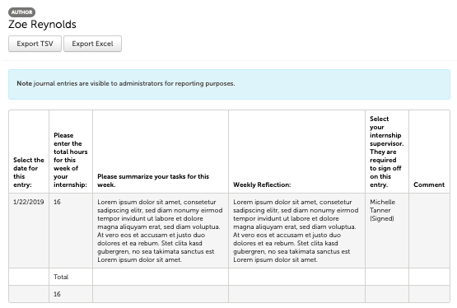
Contact our counseling field-experience office with questions: cahc_internship@niu.edu or 815-753-9344.

